linux FIle Access Permissions
The below format is the example for directory
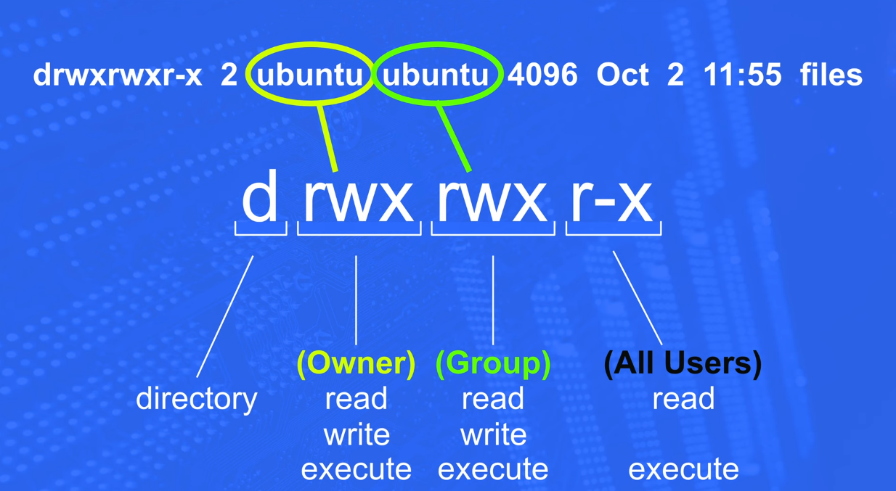
The below format is the example for File
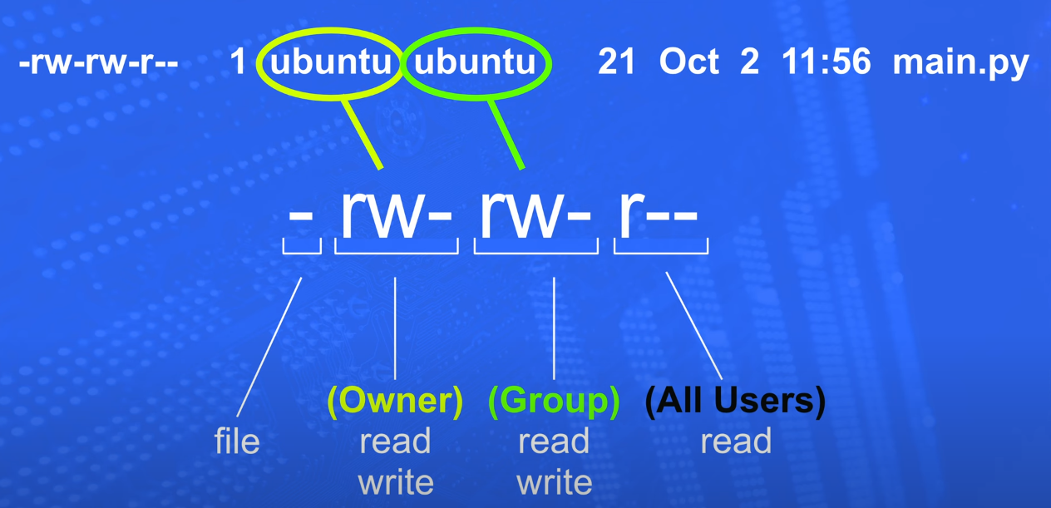
To change the ownership of the file
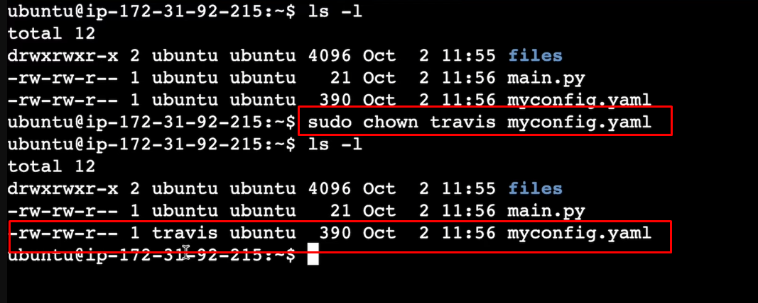
To change the ownership to group

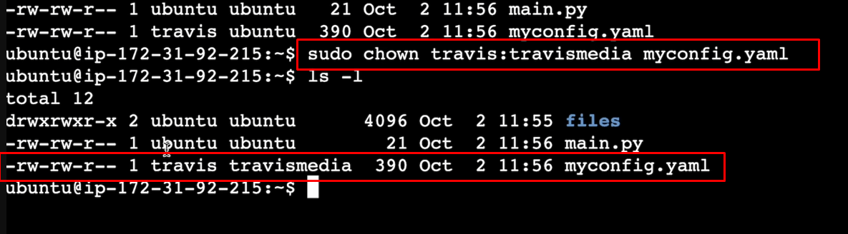
To give the access of the user
r- Read, w- Write, x- Execute

How to calculate the access
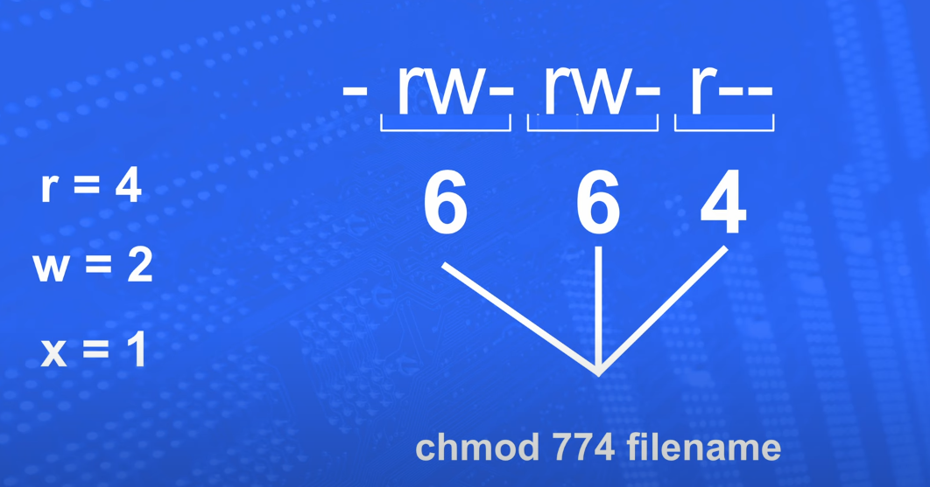
-rw-rw-r—
Breaking up the above code
-rw = 0+4+2=6
-rw = 0+4+2=6
r-- = 4+0+0=4
To give the access for the file based on the above code means use the below commend
Sudo chmod 664 filename

